## FOOD DELIVERY PROJECT REPORT

**A PROJECT REPORT**

***Submitted by***

**U Evan Steve**(24BCE10639)

*in partial fulfillment for the award of the degree of*

**BACHELOR OF TECHNOLOGY**

*in*

**COMPUTER SCIENCE AND ENGINEERING**



**SCHOOL OF COMPUTING SCIENCE AND ENGINEERING**

**VIT BHOPAL UNIVERSITY**

**KOTHRIKALAN, SEHORE MADHYA PRADESH - 466114**

NOVEMBER 2025

**TABLE OF CONTENTS**

|  |  |  |
| --- | --- | --- |
| **Chapter no.** | **Title** | **Page no.** |
| **1** | **Introduction** | **3** |
| **2** | **Problem Statement** | **4** |
| **3** | **Functional Requirements** | **5** |
| **4** | **Non-functional Requirements** | **6** |
| **5** | **System Architecture** | **7** |
| **6** | **Design Diagrams** | **8** |
| **7** | **Design Decisions and Rationale** | **15** |
| **8** | **Implementation Details** | **16** |
| **9** | **Screenshots/Results** | **22** |
| **10** | **Testing Approach** | **28** |
| **11** | **Challenges Faced** | **29** |
| **12** | **Learnings and Key takeaways** | **30** |
| **13** | **Future Enhancements** | **31** |
|  | References | **32** |
|  |  |

## CHAPTER 1

**INTRODUCTION**

Food delivery applications gives us the convenience to order food from a wide range of restaurants and get delivered at our doorstep without us stepping out of the house. Gone are the days when people had to travel to have their favourite foods from their favourite restaurants. Food can be ordered by using phone, additional delivery charge is incurred while ordering the food which is justifiable.

India’s online food delivery market was estimated about $43.47 billion in 2024 and projected as $320 billion by 2033.

Compound Annual Growth Rate of 22.25% to 23.10% is projected from 2025

The drivers for such high growth rates are smartphone penetration, shifting lifestyles, digital payments, expansion of cloud kitchen and increasing disposable incomes.

**Swiggy and Zomato are the dominant platforms holding about 88% of market share.**

Many factors are needed to woo customers to order food through applications. Few of them being user friendly, customer satisfaction, offering diverse cuisines and being budget friendly. While considering customer satisfaction, recently we have seen many complaints that the price of the food when bought from the restaurant differs from that when ordered through apps, the latter being higher. This might be a major concern, given the case that delivery charges are imposed apart from the food price. The above issue being a concern, the problem we will be handling also falls under customer satisfaction criteria. Marketing strategies are employed to woo customer to buy a product, but is goodwill compromised by doing so, is an important question to be addressed.

## CHAPTER 2

**PROBLEM STATEMENT**

The apps through which we order food, as part of their marketing strategy display only the base price of the food without all the additional charges like GST, surge fees, delivery charges on the first page and the final price is displayed in subsequent pages. This generally misleads the naïve customers. My project aims to display the final rate of the food including all charges on the first page of order.

**Example:** The first screen shot shows the price of the item as 189rs while ordering. But while checkout the final price of the item is 213rs that too after waiver of delivery charge of 19rs.

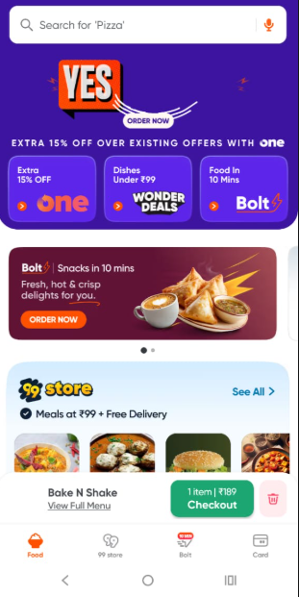 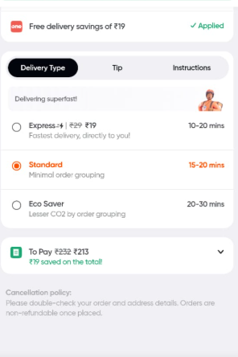

## CHAPTER 3

**FUNCTIONAL REQUIREMENTS**

Users should be able to login using either existing credentials or should be able to create a new login. The application should not give access to unregistered users. Upon authentication, the application should ensure that user can browse the menu, add items and place an order. Additionally search option should also be available for the user

Users should be able to see the final price in the first page and not in the final page of placing order. This will ensure customer satisfaction.

**Software Requirements:**

This application is developed using java,mysql

* **Operating System**: Windows 11.
* **Language**: Java
* **Database**: MySQL
* **Build Tool**:IntelliJ IDEA

## CHAPTER 4

**NON-FUNCTIONAL REQUIREMENTS**

**User friendly:**

The app should be easy to use for first-time users, with an intuitive interface.

**Speed:**

The app should load the restaurant menu in under 1 second.

**Concurrent Users:**

The system should support concurrent orders.

## CHAPTER 5

## SYSTEM ARCHITECTURE

## A food delivery app’s architecture aims to provide user friendly , seamless experience for both the customers and the restaurant partners. In our project restaurant partners are not in scope.

## Customers should be able place orders using the user interface at the outset. The application uses database to store retrieve the restaurant information.

## 1. User Interface

## The users interact with the UI layer directly after logging in. It allows to search for restaurants and food items and place order.

## 2. Backend Services

## The backend services are responsible for managing the data and logic behind the app. Backend services include authentication and authorization, order management and menu management.

## 3. Databases

## Databases are implemented for storing data about customers, restaurant partners and menu items.

## CHAPTER 6

## DESIGN DIAGRAMS

## 1.Use Case Diagram

## 

## 2.Workflow Diagram

## 

## 3.Sequence Diagram

## 

## 4.Class/Component Diagram

## 

## 

## 

## 

## 5.ER Diagram

## 

## CHAPTER 7

## DESIGN DECISIONS AND RATIONALE

## #1 Make the ordering process simple:

## The customer base we are catering to is diverse, hence the ordering process should be user friendly, practical and simple.

## #2 Provide final price in the first page of order

## Customer satisfaction is of core importance to any business. Showing base price to encourage customer to order and then when the final price is higher will dissatisfy the customer. What we quote initially should be the final price .A dissatisfied customer might become a non -returning customer.

## #3 Ensure core Java and MySql is used for the project.

## Core Java and MySql are the software requirement cited for the project and hence both these have been used to implement the project.

## CHAPTER 8

## IMPLEMENTATION DETAILS

## Home Page:The customer can either log in with his credentials or create a new account if he doesn’t have one.

## Login: In case of logging in with existing credentials the user has to enter username and password. Once the username and password are authenticated the order page is displayed.

## 

## Invalid Credentials Screen: Error message will be displayed if the login details are incorrect.

## 

## Create Account Screen: In the event of new user the user has to enter details to create an account

## 

## Account created successfully : On entering valid details in Create account page Account created successfully message box will be displayed

## 

## Evan’s food delivery App page: After successful login the order page will be displayed with the Load menu button. We can select the restaurant from the restaurant drop down menu and click load menu to view the menu available at the restaurant

## 

## Menu loaded screen:

## 

## Add to cart: Once the menu is loaded we can add the items along with the quantity required the default quantity being one.

## 

## As items are added we can immediately see the final price of the item which will be helpful for the user to decide whether to buy or not. The customer can check out the items using Checkout button.

## Order Confirmed :Once the customer clicks Checkout button the order confirmed message will be displayed with the price. Kindly note that there is no difference in the price listed on the order page and the price listed in the confirmation message box

## 

## Search Option: The application also gives the option to search items using the Search for food items text box available at the top left corner next to load menu button.

## 

## The search items are displayed depending on what is typed in the text box dynamically.

## 

## Example: typing mar in search box displays items having mar in its spelling

## CHAPTER 9

## SCREENSHOTS AND RESULTS

## 

## 

## 

## 

## 

## 

## 

## 

## 

## 

## 

## 

## 

## 

## 

## The final result screen shot will be order placed successfully message with the total amount and customer name.

## 

## CHAPTER 10

## TESTING APPROACH

## Testing is done to ensure that application is bug free , complies expected result and functions efficiently. The approach used to test Food delivery application were below

## Unit Testing: Individual modules were tested

## Integration Testing: Different modules work together seamlessly

## User Interface (UI) Testing: Ensure that the user interface is user-friendly, intuitive, and visually appealing, consistency in design elements and responsiveness across different devices.

## Performance Testing: Assess the system’s performance under normal conditions like response times

## Security Testing: Ensure that user data is handled securely, and unauthorized access is prevented.

## Usability Testing: Evaluate the project from an end-user perspective to ensure ease of use. Gather feedback on user interfaces, navigation, and overall user experience.

## Deployment Testing: Conduct tests in the production environment to ensure a smooth transition from the testing phase to live operation.

## CHAPTER 11

## CHALLENGES FACED

## Establishing the initial connection was slightly difficult. Was unable to set password after reinstalling MySQL. Then had to research to eliminate the issue.

## CHAPTER 12

## LEARNINGS AND KEY TAKEAWAYS

**Learning 1:**

**Scalability Limitations**: MySQL primarily uses a single-node architecture, which can lead to scalability issues with large datasets or high traffic. So when scaling up the project we should select paid database

**Learning 2:**

**Analytical Processing (OLAP):** MySQL is optimized for Online Transaction Processing (OLTP) and performs poorly on complex, read-heavy analytical queries compared to databases with native column-store formats.

**Learning 3:**

**Connectivity Issues:** Establishing the initial connection can be a common hurdle, often due to incorrect JDBC URLs, wrong port numbers, firewall restrictions, or the MySQL server not accepting TCP/IP connections.

## CHAPTER 13

**FUTURE ENHANCEMENTS**

With increase in complaints of difference in charges while ordering through and buying directly from restaurant, this application can be enhanced to display the difference in charges. This would help the user decide whether to order online or dine in depending on the commutation charges he has to incur by doing so.

Further enhancements can be.

**Integration of AI and Machine Learning** to suggest recommendations based on order history.

**Enhance User experience** to allow users to visualize dishes by developing augment reality features.

**Voice enabled ordering** capabilities for hands free integration.

## REFERENCES

<https://www.geeksforgeeks.org/software-engineering/food-delivery-application-project-in-software-development/>

<https://www.geeksforgeeks.org/system-design/use-case-diagram/>

<https://www.ibm.com/think/topics/entity-relationship-diagram>